**IFT 266 Introduction to Network Information Communication Technology (ICT)   
  
Lab 38**

**Backup your router**

Co-authored by Lonnye Bowyer

This lab follows on from labs 25 and 31 where you created and implemented a subnetted IPv6 addressing scheme.

You should have saved your packet tracer file after you completed lab 25/31  
If do you did not save your file, as you were instructed then you will need to redo labs 25/31

**After completing this lab, you will have completed the following (fingers crossed)**

1. Backup router configurations.
2. Replace a router and use a backup configuration file to configure it.
3. Verify the replaced router is configured correctly.

**Scenario**

You get a call on Monday morning from your manager and he expresses his concern about the age of your networking gear. Your manager wants to replace the current routers as soon as possible as they are nearing the end of support from Cisco.   
  
 You are to come up with a plan before your manager gets to the office.

You do some research and realize there are none of the router or switch configurations backed up, which means you’d have to configure these from scratch should one fail to work.   
  
You realize you will need to come up with a backup strategy for all of your networking gear.   
  
You will also need to document the steps to restore a configuration on a new device.



* + - 1. For this lab, we will concentrate on backing up two routers and we will replace one.  
           
         Open up the file you saved after completing lab 31.   
           
         If you did not save the file, then you will need to do the lab before you go any further.

Completed  (Double click on Check box and select “Checked”)

1. Open PC0 and go to the Desktop IP Configuration.

Select “Static” under IPv6 Configuration.

Select “Auto Config”. We want to make sure the “IPv6 Autoconfig request successful” message is found.   
  
If you just loaded your packet tracer file, this may take a while. You will need to wait until all of your link lights are green.

Completed  (Double click on Check box and select “Checked”)

What is the IPv6 address for PC0?

PC0 IPv6: _______________________________________________

1. Repeat step 2 for PC2.

Completed  (Double click on Check box and select “Checked”)

What is the IPv6 address for PC2?

PC2 IPv6: ______________________________________________

1. Confirm you can successfully ping PC0 from PC1 and PC2 from PC3. This ensures the routers and switches will be able to write their config files to the PCs.

Completed  (Double click on Check box and select “Checked”)

1. Save the router startup configurations to a nearby PC.

On Router 0, open CLI and run the following:

Router#

Router#copy running-config startup-config

Destination filename [startup-config]?

Building configuration...

[OK]

Router#copy startup-config tftp:

Address or name of remote host []? ENTER IPv6 for PC0

Destination filename [Router-confg]? Router0-config

Writing startup-config...!!

[OK - 1024 bytes]

Completed  (Double click on Check box and select “Checked”)

1. Repeat step 5 for Router 1. Save the config as Router1-config and save to PC2

Completed  (Double click on Check box and select “Checked”)

1. Now we will add a new router to our existing topology as follows:

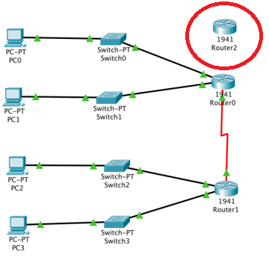

Completed  (Double click on Check box and select “Checked”)

1. Disconnect the cables from Router0 to Switch0 and Switch1, and from Router0 to Router1. Your topology will now look like this:

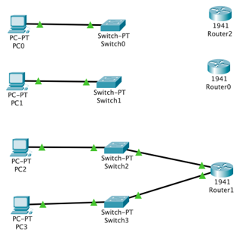

Completed  (Double click on Check box and select “Checked”)

1. Add a serial port to Router2 (requires power off/on).

Once you’ve added the serial port, connect Router2 to Switch0, Switch1, and Router1.

Move Router0 out of the way.

Be sure to connect G0/0 to Switch0 and G0/1 to Switch1.

Connect PC0 (RS 232) to Router2 (Console) via a console cable.

Your updated topology should look like the following

Completed  (Double click on Check box and select “Checked”)

1. Open PC0 and go to Terminal. Leave the default settings and Select OK. You will connect to the console of Router2. When you connect, you will be at the startup message for the router. Enter NO for the message about initial configuration.

Completed  (Double click on Check box and select “Checked”)

1. We will need to configure the ipv6 address for the link to the PC0 (and bring the link up) in order to be able to upload the config file.   
     
   Configure the router with the following commands

Router>en

Router#conf t

Enter configuration commands, one per line. End with CNTL/Z.

Router(config)#int g0/0

Router(config-if)#ipv6 address FE80::1 link-local

Router(config-if)#ipv6 address 2001:DB8:ACAD:C8::/64

Router(config-if)#no shut

Router(config-if)#

%LINK-5-CHANGED: Interface GigabitEthernet0/0, changed state to up

%LINEPROTO-5-UPDOWN: Line protocol on Interface GigabitEthernet0/0, changed state to up

Completed  (Double click on Check box and select “Checked”)

1. Now, we will load the config file and restart the router.   
     
   Follow these steps:

Router#copy tftp running-config

(The next line should be the ipv6 address of PC0)

Address or name of remote host []? 2001:DB8:ACAD:C8:201:42FF:FEC9:2DBB

Source filename []? Router0-config

Destination filename [running-config]?

Accessing tftp://2001:DB8:ACAD:C8:201:42FF:FEC9:2DBB/Router0-config...

Loading Router0-config from 2001:DB8:ACAD:C8:201:42FF:FEC9:2DBB: !

[OK - 1024 bytes]

1024 bytes copied in 0.014 secs (73142 bytes/sec)

Router#

%SYS-5-CONFIG_I: Configured from console by console

Completed  (Double click on Check box and select “Checked”)

1. We will now want to copy the running configuration to the startup configuration. This is important so we don’t lose the configuration we just loaded.

Router#copy running-config startup-config

Destination filename [startup-config]?

Building configuration...

[OK]

Completed  (Double click on Check box and select “Checked”)

1. Now – let’s reboot the router.

Router#reload

Proceed with reload? [confirm]

Completed  (Double click on Check box and select “Checked”)

1. The router will restart. Once you get to the “Return to get started!” message, we will need to login and bring the other links (G0/1 and S0/1/0) up to complete the restore process.   
     
   Please do the following:

Press RETURN to get started!

Router>en

Router#conf t

Enter configuration commands, one per line. End with CNTL/Z.

Router(config)#int g0/1

Router(config-if)#no shut

Router(config-if)#

%LINK-5-CHANGED: Interface GigabitEthernet0/1, changed state to up

%LINEPROTO-5-UPDOWN: Line protocol on Interface GigabitEthernet0/1, changed state to up

Router(config)#int s0/1/0

Router(config-if)#no shut

Router(config-if)#

%LINK-5-CHANGED: Interface Serial0/1/0, changed state to up

Router(config-if)#

%LINEPROTO-5-UPDOWN: Line protocol on Interface Serial0/1/0, changed state to up

Completed  (Double click on Check box and select “Checked”)

1. You should now be able to ping PC1 from PC0. If not, troubleshoot and resolve.

Completed  (Double click on Check box and select “Checked”)

1. Disconnect the console cable from PC0 to Router2. Delete Router0. You’ve successfully replaced your router!

Completed  (Double click on Check box and select “Checked”)